**GENERAL SURGERY**

**Department Signage:**





**About the Department/Division:**

The Department of General Surgery at AIIMS Bhubaneswar is officially functional since 2013. The current strength of faculty member is 10 at present. The department has two units, namely Unit 1 & unit 2 led by Prof. Dr Tushar S. Mishra and Professor & HoD Dr Manash Ranjan Sahoo respectively. The department runs OPD on all working days & provide trauma & emergency services 24 hrs a day. The department has well equipped functional minor & major OTs in which spectrum of basic and advanced open & laparoscopic procedures are performed. The department has now extended its services to the satellite centre at Balasore. The department currently offers Post graduate and PDF course in General surgery and Minimal access surgery respectively. The department regularly conducts academic activities like seminars & journal club. All faculty members are actively involved in ther teaching research and patient care.

**Message from the Head of the Department/Division:**

I consider it as a pleasure and a responsibility to lead this young department as one amongst all the faculty members and with a vision to improve and upgrade the academics and patient care in the department in a disciplined manner so that people's and students' expectation can be met. Though it’s always a challenge to achieve the vision still I believe with the blessings of almighty and cooperation from all quarters we will be able to reach our goal.

**Faculty/Staff**

|  |  |  |  |  |  |
| --- | --- | --- | --- | --- | --- |
| S.No | Name | Designation | Department | Email | Action |
| 1 | Dr Manash Ranjan Sahoo | Professor & Head | General Surgery | Surg_Manash@aiimsbhubaneswar.edu.in |  |
| 2 | Dr Tushar Subhadarshan Mishra | Professor | General Surgery | [Surg_Tushar@aiimsbhubaneswar.edu.in](mailto:Surg_Tushar@aiimsbhubaneswar.edu.in) |  |
| 3 | Dr Shantanu Sahu | Professor | General Surgery | [Surg_Shantanu@aiimsbhubaneswar.edu.in](mailto:Surg_Shantanu@aiimsbhubaneswar.edu.in) |  |
| 4 | Dr Prakash Kumar Sasmal | Additional Professor | General Surgery | [Surg_Prakash@aiimsbhubaneswar.edu.in](mailto:Surg_Prakash@aiimsbhubaneswar.edu.in) |  |
| 5 | Dr Mithilesh Kumar Sinha | Additional Professor | General Surgery | [Surg_Mithilesh@aiimsbhubaneswar.edu.in](mailto:Surg_Mithilesh@aiimsbhubaneswar.edu.in) |  |
| 6 | Dr S Manwar Ali | Additional Professor | General Surgery | [Surg_Manwar@aiimsbhubaneswar.edu.in](mailto:Surg_Manwar@aiimsbhubaneswar.edu.in) |  |
| 7 | Dr Pankaj Kumar | Associate Professor | General Surgery | Surg_Pankaj@aiimsbhubaneswar.edu.in |  |
| 8 | Dr Pradeep Kumar Singh | Assistant Professor | General Surgery | [Surg_Pradeep@aiimsbhubaneswar.edu.in](mailto:Surg_Pradeep@aiimsbhubaneswar.edu.in) |  |
| 9 | Dr Bikram Rout | Assistant Professor | General Surgery | [Surg_Bikram@aiimsbhubaneswar.edu.in](mailto:Surg_Bikram@aiimsbhubaneswar.edu.in) |  |
| 10 | Dr Monika Gureh | Assistant Professor | General Surgery | [Surg](mailto:surg_monika@aiimsbhubaneswar.edu.in)_Monika@aiimsbhubaneswar.edu.in |  |

**Major Achievements:**

*Residents Outstanding performances:*

1. Our first Post graduate, Dr Shritosh Kumar presented his thesis, “ERAS in Gastrectomy-A Randomised Clinical Trial, “at the 48th World Congress of Surgery held at Krakow Poland in 2019. His paper was adjudged as the best Paper and awarded the Graham Hill’s prize.
2. Dr Shritosh, Dr Ankit, Dr Harshavardhan, Dr. Sanhita, Dr. Pranav are the PG Alumni’s who are pursuing MCh course in various reputed institutes of India.
3. Many Senior residents are also pursuing MCh course and some have joined other institutes as Assistant Professors.

*International Conferences organized:*

1. The department organized an international conference on Breast, “ASOMACON 2019 from 14th November 2019 to 17th November 2019, at AIIMS, Bhubaneswar.

*National Conferences/Workshop organized:*

1. The department conducted the Fellowship of Minimal Invasive Surgery course for the Surgeons and the Gynaecologists from 11th April 2019 to 14th April 2019, at AIIMS, Bhubaneswar.

*Achievements and awards (Faculty):*

1. Dr Manash Ranjan Sahoo
   1. Sectional Editor of Journal of Minimal Access Surgery, a pubmed & science citation indexed journal only one on minimal access surgery from Asia Pacific region.
   2. Selected to receive Fellowship of American College of Surgeons in October 2022.
2. Dr Prakash Kumar Sasmal
   1. Received the 1st Prize in the faculty paper presentation titled, “Laparoscopic management of insulinoma of the pancreas: Tips and Techniques” at 79th Annual Conference of Association of Surgeons of India held at Bhubaneswar from 18th-21st Dec, 2019.
   2. Successfully cleared the Fellowship exam of Colorectal Surgeons of India and became the first FACRSI from the Odisha state.
3. Dr S.M Ali
   1. Awarded FAIS from Association of Surgeons of India December 2019.
4. Dr Pankaj Kumar
   1. Awarded with “Fellowship in Minimal Access Surgery (FMAS)”, a prestigious fellowship program by Association of minimal access surgeon of India (AMASI).
   2. Awarded with Best poster presentation for the “FRAIL Trial”, at St. Galen, Switzerland during the European Colorectal Congress 2020.
5. Dr Pradeep Kumar Singh
   1. Awarded with “Fellowship in Minimal Access Surgery (FMAS)”, a prestigious fellowship program by Association of minimal access surgeon of India (AMASI).
6. Dr Bikram Rout
   1. Awarded the EFIAGES fellowship in June 2019.

**Other details:**

1. *Academic Courses:*

MS (General Surgery) &

PDF (Minimal Access Surgery)

1. *Special Clinics:*

Colorectal

Breast & Endocrine

Hernia

Metabolic Surgery

Wound care clinic

Hepato-pancreatico-biliary (HPB)

1. *PG Students:*

Six students per year

Current: 12

Alumni: 9

1. *PDF Course:*

Two candidates per year

Current: 1

Alumni: 2

1. *Senior Residency:*

The department offers three years Senior residency in General Surgery.

Allotted strength is 24 per year.

**Media Gallery:**

1. *Photos*

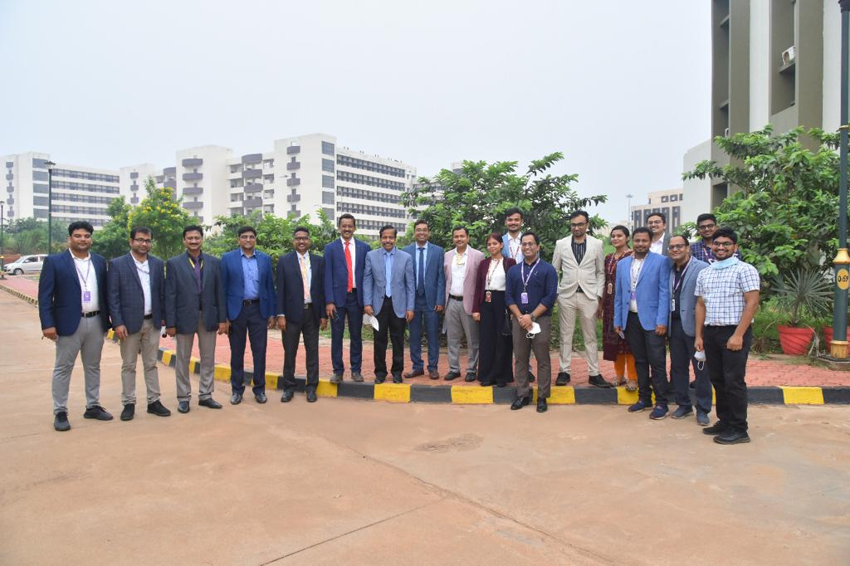

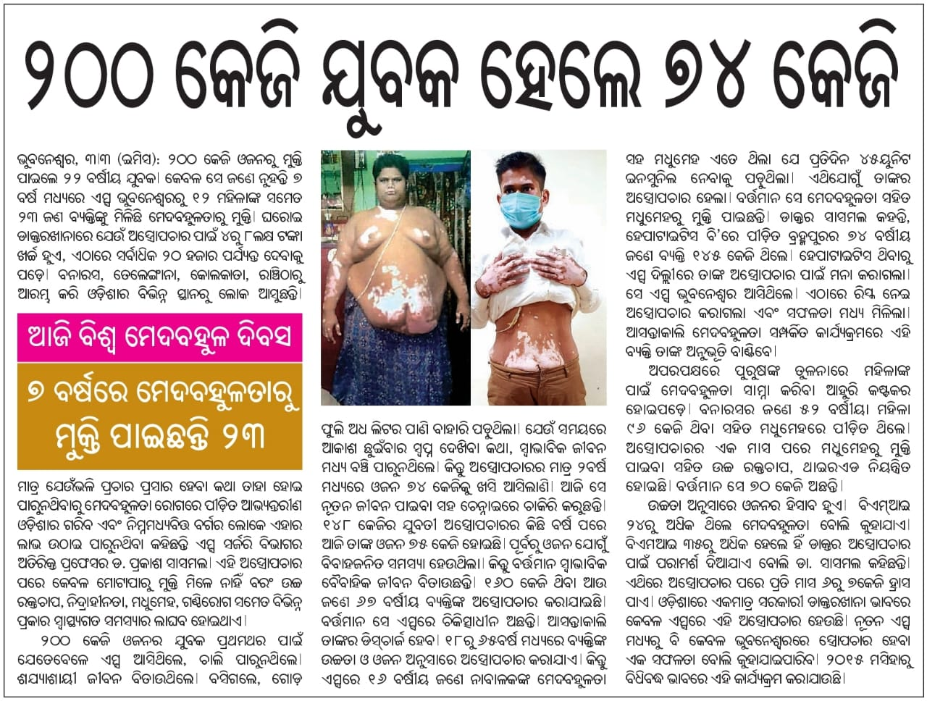

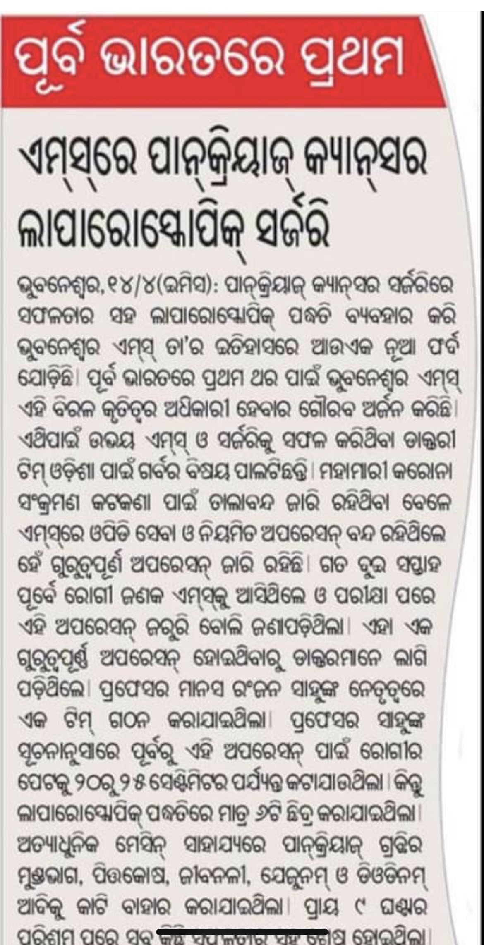

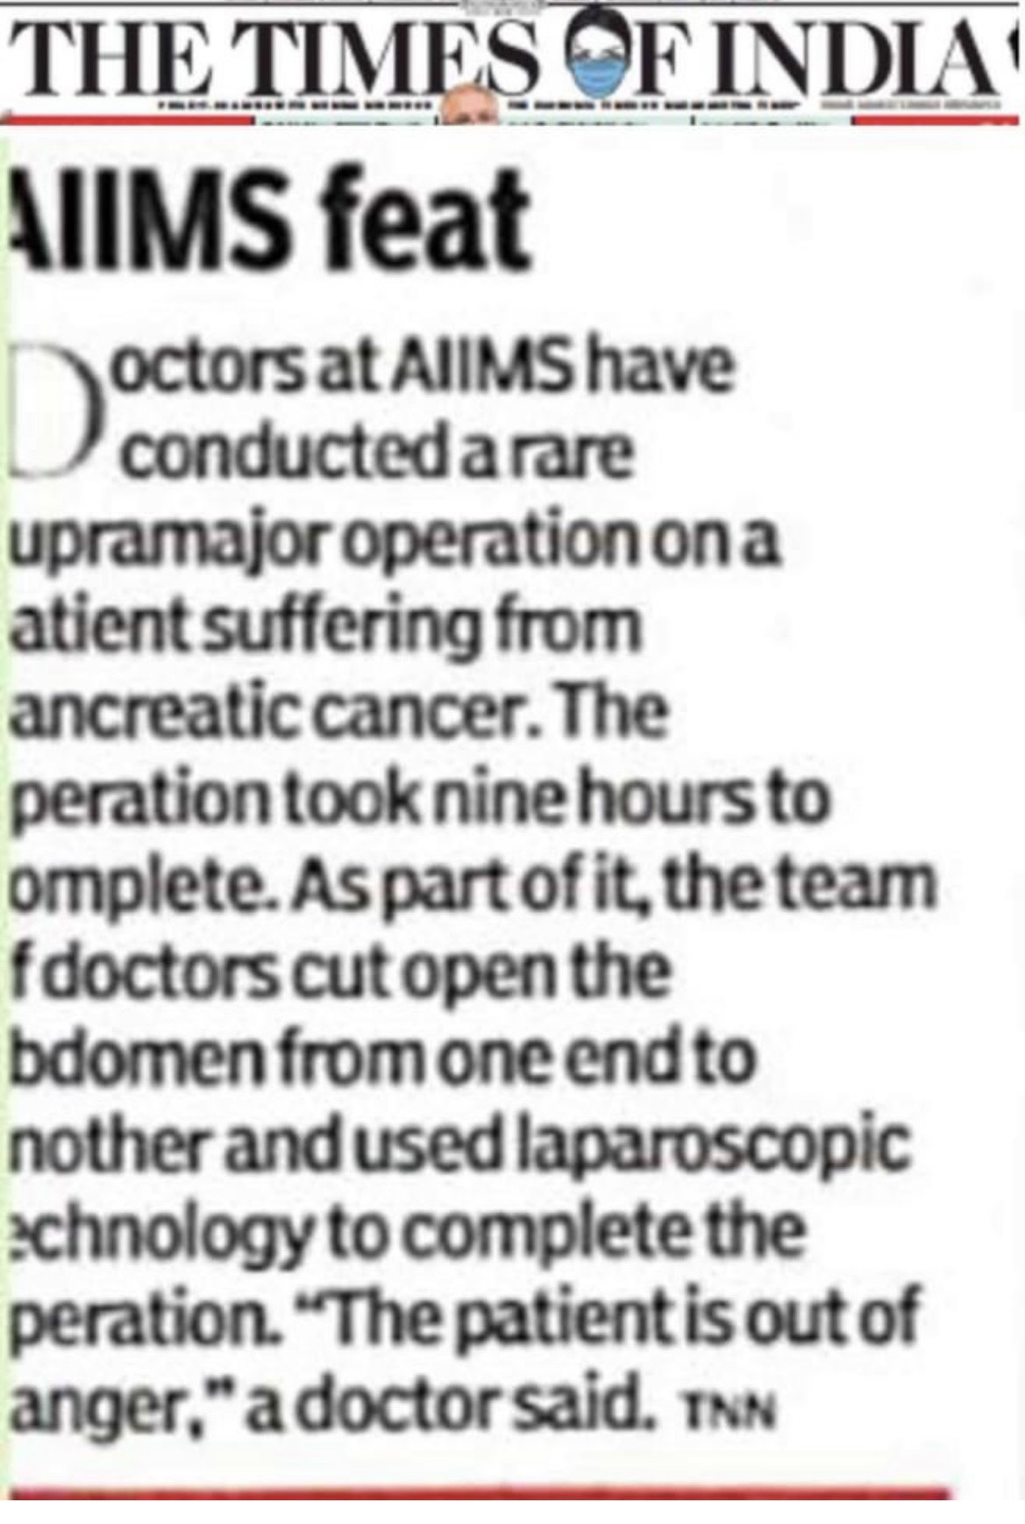

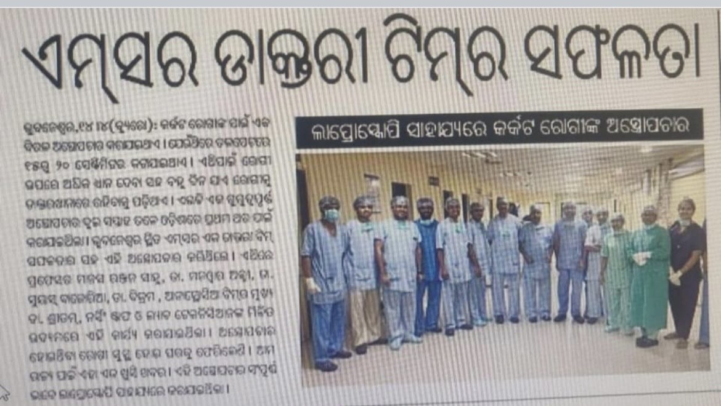

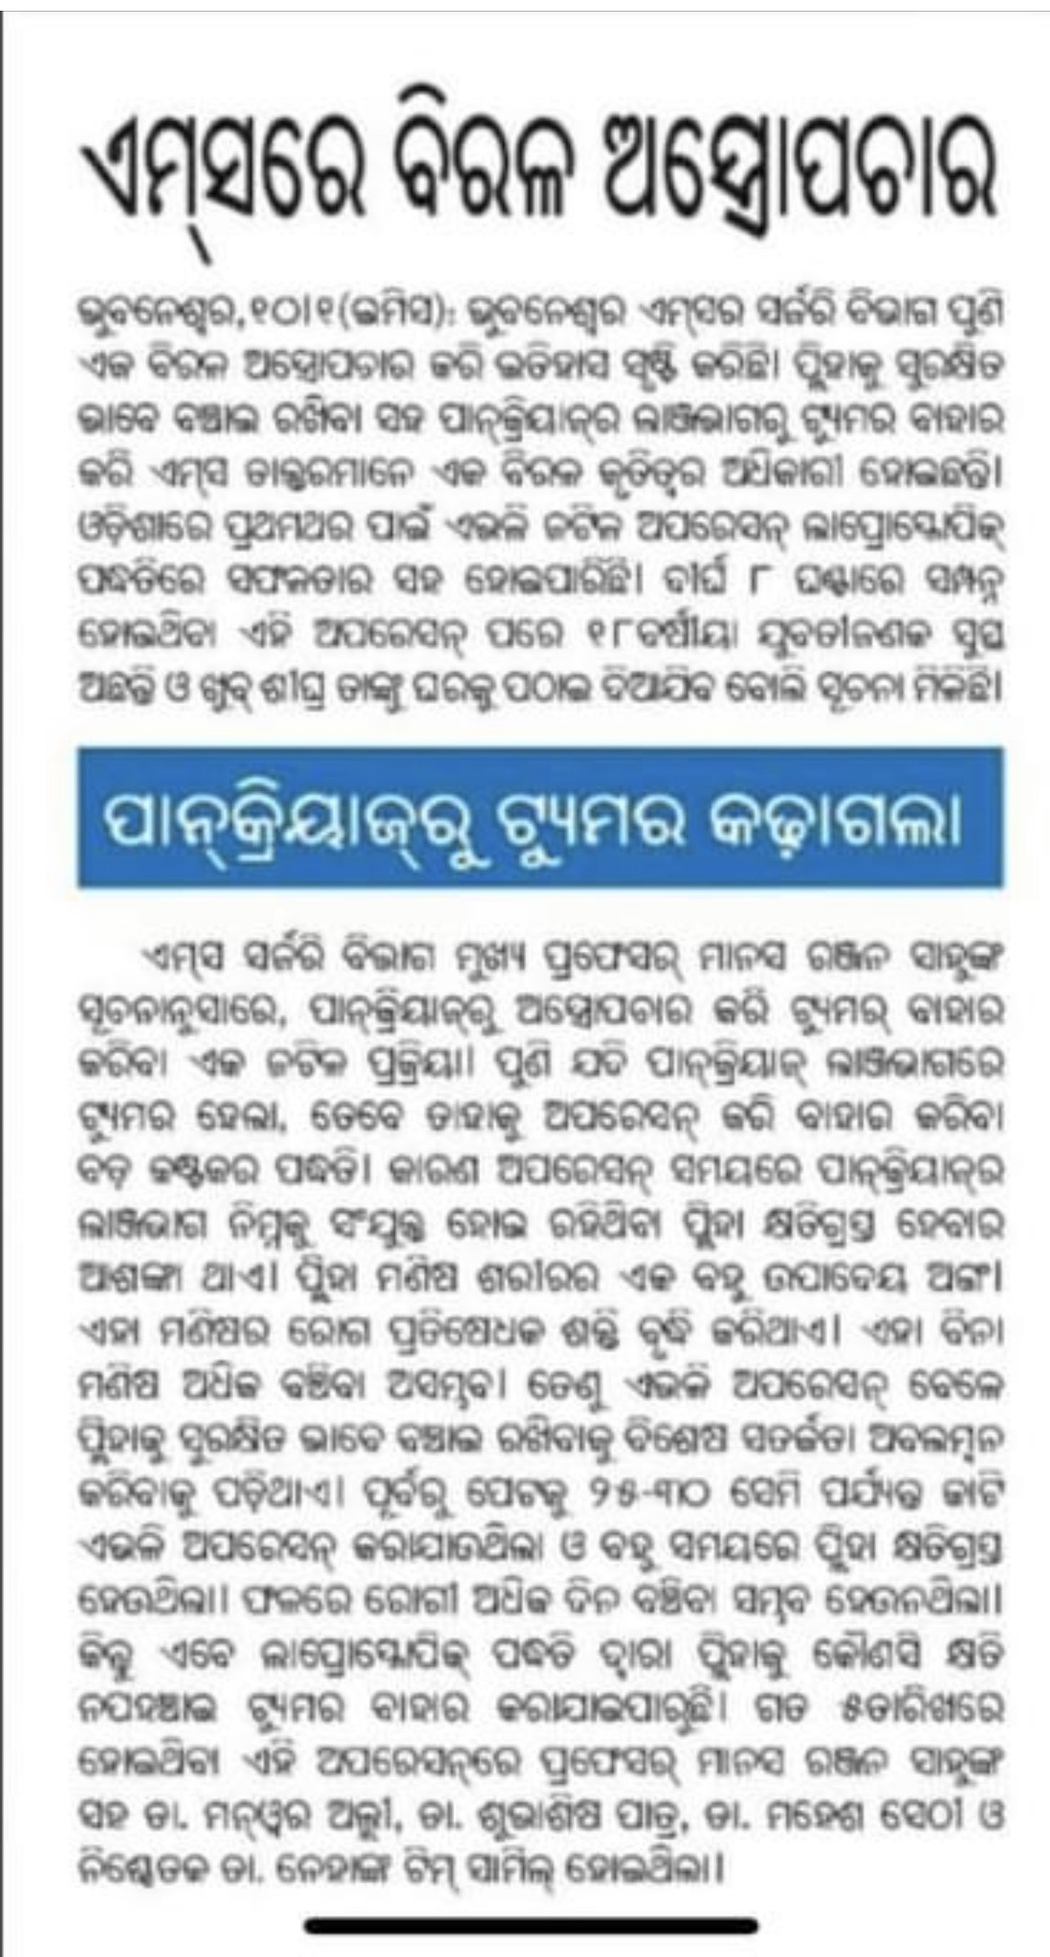

1. *Video Links*
   1. <https://www.youtube.com/watch?v=hk_ndj_dw3s&authuser=0>
   2. <https://fb.watch/bxLhRuFqWS/>
   3. <https://www.youtube.com/watch?v=VB_nC06u1qE>
   4. <https://fb.watch/byxC7J_2Bh/>
   5. <https://timesofindia.indiatimes.com/city/bhubaneswar/state-sees-rise-in-bariatric-surgeries-in-past-7-years/articleshow/90004069.cms>
   6. <https://fb.watch/byChExBIj5/>
   7. <https://fb.watch/byEvxSmJ0Q/>
   8. <https://fb.watch/bCMlGiszJo/>
   9. <https://www.youtube.com/watch?v=VB_nC06u1qE&authuser=0>